Sheridan Dela Cruz
May 2, 2026
Module 8.2

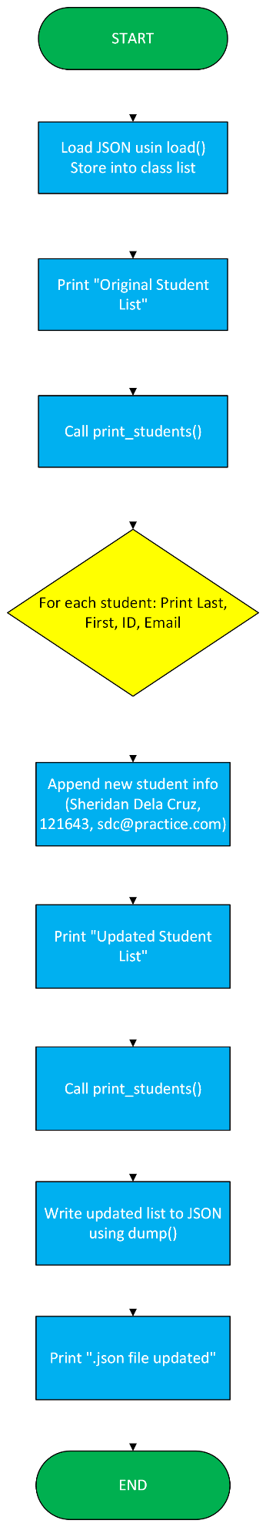

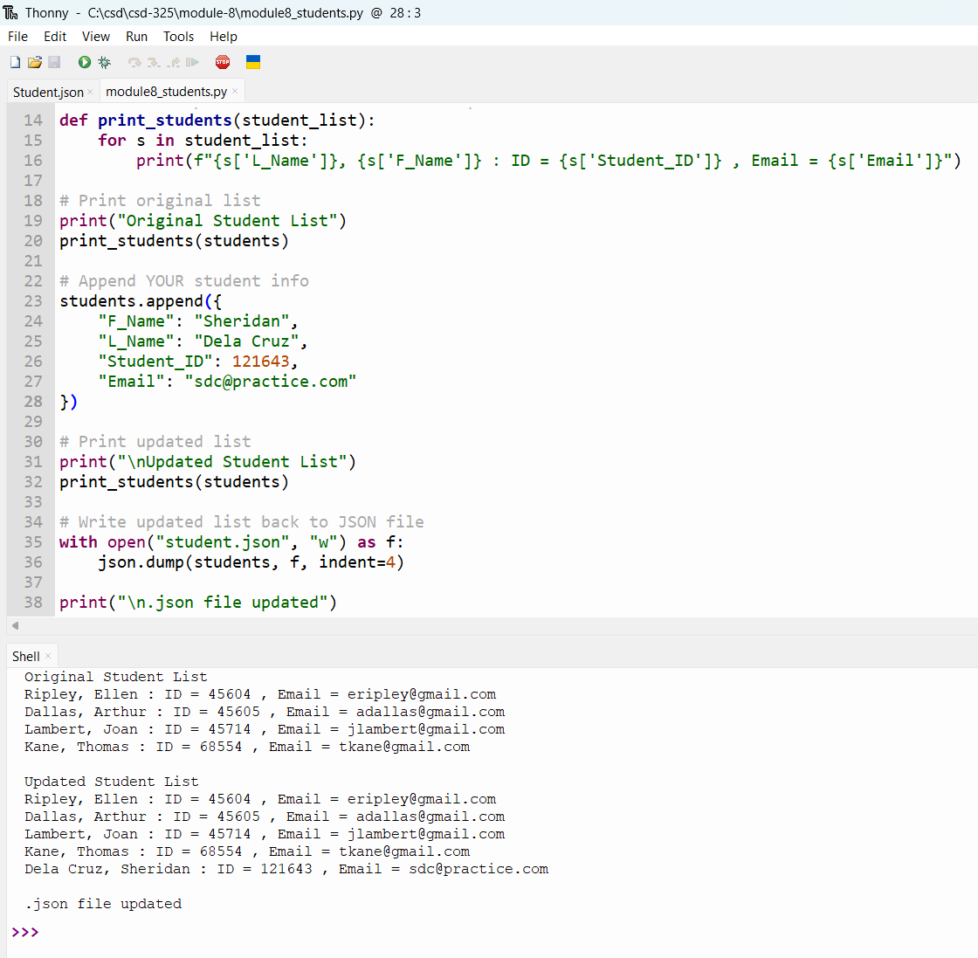

Thonny did not show a file-change notification, but here is a screenshot of the updated JSON file showing the change.

